AN INTRODUCTION TO COMPOSITE IMAGES WITH LAYERS & MASKS
This is an introduction to the complex world of creating images using layers, masks and blending tools using Photoshop, which I access via Creative Cloud so is the latest version of Photoshop, CC2015. Most of these features are however available in earlier versions – if their location is different.

The beginning and the end…
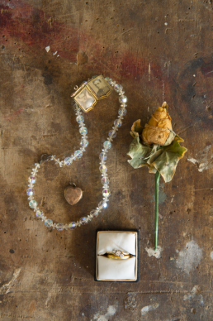 |  |  | 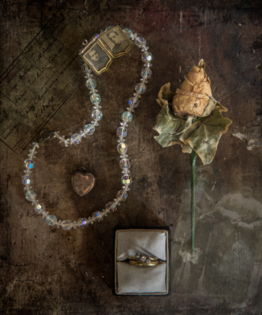
This is the ‘base’ image and its final version. First of all the RAW base image was processed in Lightroom (which is my software of choice) and opened in Photoshop (Ps). It could of course have had that first edit in Ps. It then has four different elements added to it.

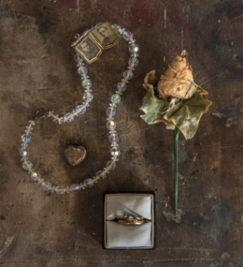 | 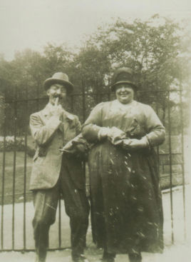 |  | 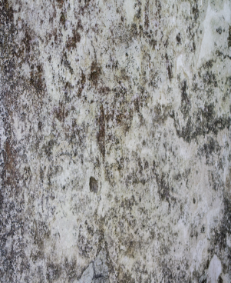
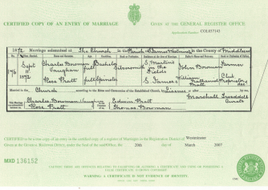 | So that’s the base image, a couple, a texture (and we’ll look at different textures), a border and a marriage certificate.
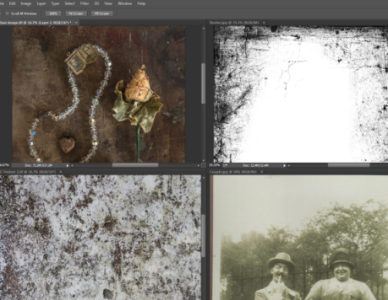 |  | Open all the images in Ps. You can arrange the images using the ‘window/ arrange’ tab, or simply open them all in ‘tab’ mode so that your working space, that is the base image, is maximised.
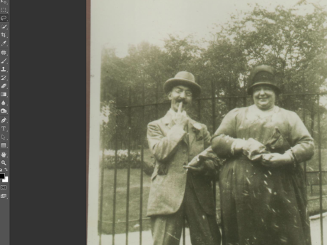 |  | Starting with the image of the couple, we will build the final image, by selecting a part of the couple image. There are many ways to select parts of images – an entire Digital session could be spent on that! For this exercise I only need a rough selection using the lasso tool.
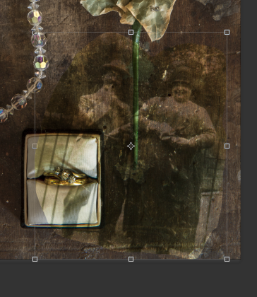 |  | You can drag and drop or copy and paste, then using the ‘move tool’, resize, rotate, or move the imported image as you wish. Double click inside the ‘bounding box’ to apply the move.
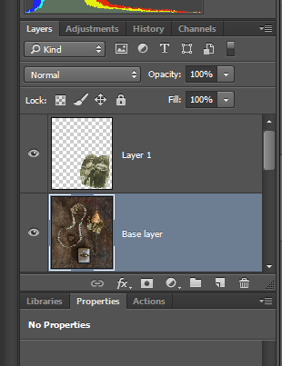 |  | You’ll see that importing the image of the couple has created a new layer, which we can rename. But we also need to select the blend mode that will work best with this imported image. The blend mode is shown here, and with the ‘fill’ percentage, are important to the final look.  Check the move tool, hold down the shift key and the plus and minus keys will let you scroll through the blend modes. Some will be completely unsuitable, some possible and those will need different percentage fill.  The outline of the imported image is too sharp and it overlaps the base image, so we need to create a ‘vector mask’, by clicking here.
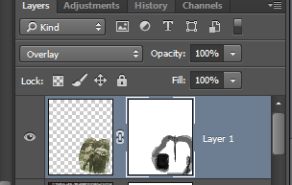 |  | In this example, you can see the blend mode is ‘overlay’ at 100%. Using a ‘brush’ with black, I have painted a mask that is 100% to clear the imported image over the rings, but graduated around the edge of the picture.  If you chose to move the imported image later, the mask will move with it.
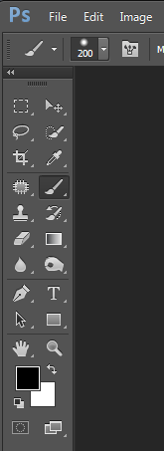 |  | Here are: -  - The brush selector  - The brush tool  - The colour selector
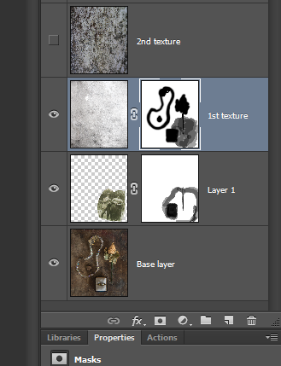 |  | Next, import the texture layer. There are two different textures, they will both sit on a different layer – one renamed 1st texture – the other 2nd texture. Again, the blend mode and % fill will need to be decided.  The first texture is turned on (has its ‘eye’ open) so is affecting the image. It also has a vector mask that has taken the texture off of critical parts of the base image.  You can move a vector mask from one layer to another by dragging and dropping, or copy it with Ctrl (cmd on a Mac) and Alt, drag and drop.  You can then turn the two layers on and off to select the preferred texture.
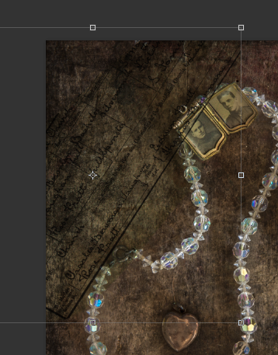 |  | Then, import a selection of the marriage certificate; select the blend mode (Multiply in this case) and the fill (100%).  Create a vector mask to take the image off of those parts of the image you want clear, ie the locket and the necklace, and any edge softening you want.  You can return to other layers throughout the process – as the image is built you might well want to make further adjustments.
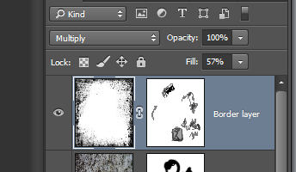 |  | Finally – import the border, and once more select the blend and fill modes, here ‘multiply’ at 57%. Create a vector mask and take any parts of the border off that you don’t want.  You might wish to make final adjustments using the other adjustment tools in Ps, then you can save the image in tiff with the layers open to work on later – or flatten to a single image.
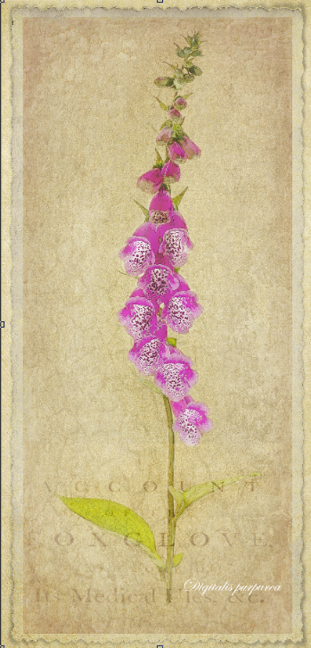 |  | 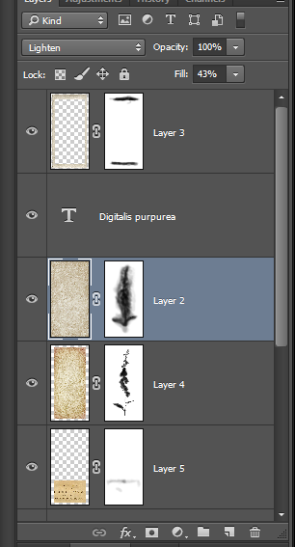
This image is also a composite created using a ‘base’ image which had already had filters applied in Ps, with two textures, a text image and a border.

